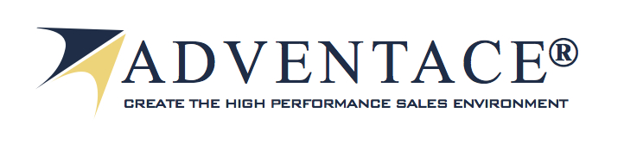
An Introduction to Adventace® LLC

- About Adventace®

We are a global sales management consulting firm whose promise is to help our clients Create the High Performance Sales Environment®. To fulfill that promise we bring our values, mission, vision, people, and our System.
  - Our Values
We are passionate about leadership, teamwork, making a difference, and the measurable success we bring to our clients. We will never compromise our integrity, our respect for both our clients and our team, and our commitment to the highest of standards. Each of us at Adventace embraces these values as we strive for excellence in everything we do. Our commitment unyielding: We will strive to deliver, as promised, sustainable, measurable results.
  - Our Mission
Driven by our values, our mission is to make a measurable difference through our ability to help our clients Create the High Performance Sales Environment®. We shall strive to deliver a sense of confidence, measurable performance improvement, control, and predictability across the sales operation. Our mission is to help our clients create a culture backed by an effective infrastructure, reinforcement processes, and the right elements of leadership, to be able to effect a great positive change and to maintain long-term sustainable sales success.
  - Our Vision
Our Vision is to be recognized as the preeminent sales and sales operations consulting firm in the world based on the measurable impact we have on our clients. We strive to be considered to be the company with the most comprehensive and innovative intellectual property in our industry, along with the most powerful network of associates. We continually enhance our offerings to ensure an increasing positive impact on our clients’ success.

As part of our vision, we strive to “move the industry forward” as a preeminent thought leader. For a set of examples of Adventace® as a thought leader, along with the success our clients have achieved, please review the links below:
    - Industry Leadership
- Blog Articles
Research Sets High Water Mark for Sales Operations
The Keys to Making Your CRM a Success
Accurate Forecasting: Is it Really an Oxymoron?
Sales Pipeline Management (first of a 3-part series)
10 Steps to Create the High Performance Sales Environment®
Managing Sellers Using Surgical Performance Metrics
- Video Services
Skill Development
Surgical Performance Metrics
A/B Ratio
Opportunity Stages
    - Client Success
"Compelling" Success at SolidWorks!
TransUnion Success with Adventace® Methodology & Application
  - Our People
We are a people-centric company: A team strengthened by attracting, nurturing, and growing people with exceptional knowledge of sales leadership, process and operations. As such we strive to achieve extraordinary performance for our clients. Our innovative organizational design maximizes our ability to produce exceptional results for our clients. Our culture is one that fosters open and honest communication, innovation and creativity, teamwork, and collaboration. We reward independent, self-sustaining, highly capable thought-leaders who are committed to both our clients’ and each other's success. We believe we have created an environment in which each of our associates is inspired, committed, and energized in a way that continues to fuel the success of Adventace and our clients. We continually invest in our associates, our products, and our services, to ensure that Adventace maintains and grows its leadership position.

Our network of Associates is comprised of 40 consultants / facilitators operating out of locations around the world. Our people average 25+ years of experience. Over 90% have very strong backgrounds in:
- Technology
- Personal selling
- Consulting
- Sales management.
Many of us have held CXO level positions.
  - Our System
We help our customers Create the High Performance Sales Environment® through the Adventace 1-2-3 System™. That System is comprised of:
- Holistic sales, sales management, and channel management “how to” skills based methodology,
- CRM application, and
- Change management services.

This triad of components that make up the Adventace 1-2-3 System™ serve several audiences:
Adventace® Audiences
    - Holistic Methodology
Our methodology provides a top-down, holistic approach to running the entire sales operation, allowing executives to create a successful sales culture based on continuous metric-driven performance improvement.

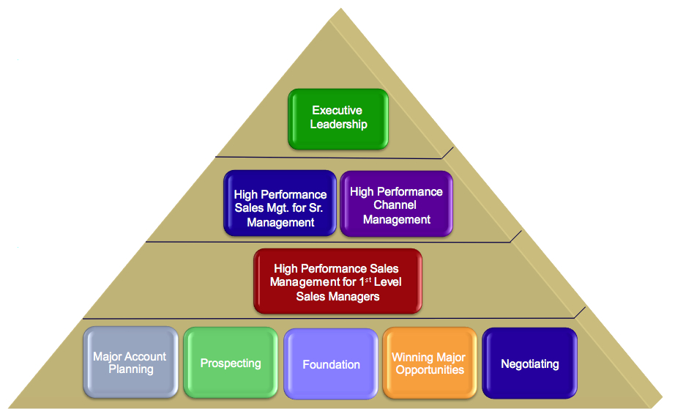
Main Programs of Holistic Methodology
It consists of processes, tools, and knowledge repository integrated into a holistic methodology. It is designed to impact the entire sales operation along with organizations that have a key interface with sales (i.e., Finance, Human Resources, Marketing, Services and Support, Product Development, etc.).

The methodology has evolved over the past two decades to become very broad and deep. This represents great advantage to our clients when it comes to program design. Based on their requirements we are able to rapidly “pull together” highly customized training programs.

The layered approach in the diagram depicts the critical targeted groups the methodology is designed to help. Those layers and the programs within are briefly described below.

Executive Leadership Layer
The key program in the Executive Leadership layer is Executive Leadership: Optimizing Your Sales Operation. The key objectives are to help Executives understand how to create a "High Performance Sales Environment", where they can confidently achieve their growth objectives and achieve predictable results, and help their sellers and sales managers measurably and in a sustained manner improve their performance. It also helps them identify the key leading performance metrics Executives should track, provides a proven approach to transition to the HPSE, shows Executives the key role they play in the successful implementation of a HPSE, discusses the results that can be expected if implemented properly, introduces them to the skills their sales management team will acquire and, and shows them how the HPSE is designed to help them solve a variety of complex management and sales difficulties.

Management Layer
The management layer of the methodology is designed to help both direct sales managers and channel managers. For direct sales managers, Adventace provides a program entitled, High Performance Sales Management. In this program, managers learn the Five Pillars of Sales Management. For channel managers who manage an indirect sales team, Adventace provides a program entitled, High Performance Channel Management. In this program, channel managers learn the Four Pillars of Channel Management.

Sales Layer
The Sales Component of the methodology provides sales people with both planning and execution programs. These programs include:
- Planning Programs
  - Territory Planning
  - Account Planning & Management Program (AMP)

- Execution Programs
  - Prospecting
  - Foundation
  - Winning Major Opportunities (WMO)
  - High Performance Negotiating.

Our methodology has been translated into 11 languages.
    - The Supporting End-to-End CRM (Adventace® SMS)
Through the Salesforce.com AppExchange, we have integrated and automated our entire holistic methodology into the Adventace® Sales Management System (SMS). This application is a complete, end-to-end sales management system.

For Executives
Using operationally critical leading performance metrics (KPI’s), executives are better able to drive their entire sales operation top-down.

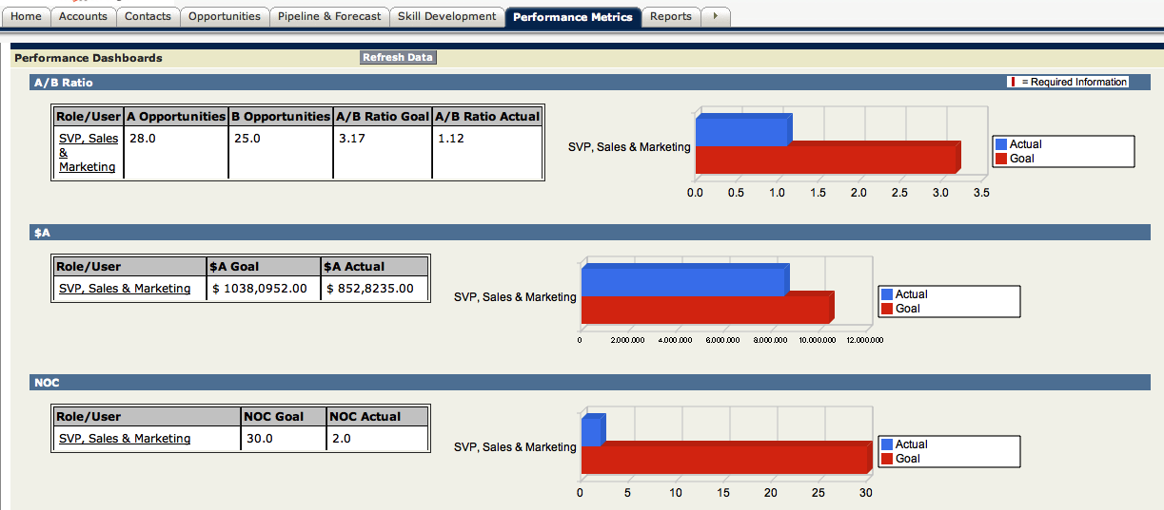
Key Performance Metrics to Help Executives Drive Operation Top-Down

For Sales Managers
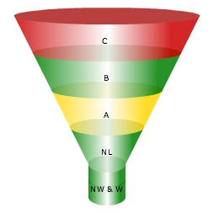
SMS provides sales managers with the ability to rapidly:
- Assess opportunities and make surgical recommendations.
- Help sellers balance their pipelines.
- Accurately forecast, and
- Develop the skills of their sellers.
Pipeline Management

For Sales People
To help sales people, we have automated our sales process in SMS. Now, in a matter of minutes, using our expert system interface, sellers can generate key opportunity information in minutes. This allows them to quickly generate sell cycle control letters to send to their buyers that summarizes:
- All key Need Development elements the buyer and seller discussed
- An Action Plan, identifying the sequence of events leading to a buy decision
- An Impact Tree™, showing the interdependence of the issues between key buyers.

For more information please take a look by going to Adventace SMS.
    - Change Management
We view Change Management as a structured approach to help individuals, teams, and the organization transition from their current state to a desired future state: The High Performance Sales Environment®. Our Change Management services are the final key component of the Adventace 1-2-3 System™.

Many executives have personally witnessed failed attempts at improving the performance of a sales operation. The most common reason is the failure to address critical change management issues in a post-training environment. Change for most people is quite difficult, whether it is at the personal or organizational level. And, when converting to any improved method, one must confront bad habits, the difficulty in real buyer situations of utilizing new and better procedures in the field, and even dramatically different ways of dealing with buyers.

Our Change Management services include:

The Operations Review
The “Operations Review” ensures that successful habits are being driven top-down through all levels of the organization. Only field data from live opportunities and actual pipeline information is assessed (Promoter Letters, Power Promoter Letters, Action Plans, Pipeline Balance Algorithm, metrics such as the A/B Ratio, Skill Analyzer, Personal Development Plans, etc). It is delivered through a series of structured webinars, on-site reviews, and one-to-one coaching.

Coaching Checkups
Our consultants are highly experienced in coaching sales managers, typically in a 1-to-1 environment. A broad range of topics can be covered to address specific needs of a manager:
- Transition issues
- Difficult employee situations
- Compensation
- Analytical/pipeline.

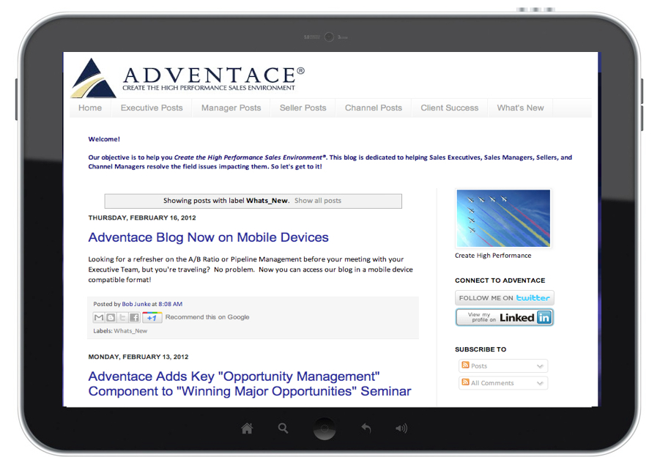
The Adventace Blog
Our blog is 100% dedicated to helping Sales Executives, Sales Managers, Sellers, and Channel Managers resolve the field issues impacting them.

Provided below is an overview of some of the topics covered on our blog:

Executive Posts
- "Accurate Forecasting": Is it Really an Oxymoron? (Not if You Follow This Plan)
- Research Sets High Water Performance Mark for Sales Operations
- The Keys to Making Your CRM a Success.

Managerial Posts
- Managing Sellers Using Surgical Performance Metrics
- THE Key Performance Metric: The A/B Ratio, Part 1: Calling Below the Power Line
Seller Posts
- Prospecting to Create Interest-Combining Art and Science
- How Buyers Buy Complex Solutions
- Opportunity Assessment

Channel Manager Posts
- Using Gap Analysis to Optimize Channel Performance

Our Video Channel
Our YouTube channel is also 100% dedicated to helping Sales Executives, Sales Managers, Sellers, and Channel Managers resolve the field issues impacting them. Provided below is a sample of the video topics covered:
- Opportunity Stages
- Surgical Performance Metrics
- The A/B Ratio
- Surgical Performance Metrics”.

The Adventace 1-2-3 System™ enables our clients to:
- Better drive the sales operation top-down using leading, surgical performance sales metrics
- Have an accurate objective view into the sales pipeline
- Improve the accuracy of sales forecasting
- Assess and develop critical skills for Sales Managers, Channel Managers, and Sellers
- Transition from product providers to solution providers
- Reduce the time-to-first-sale
- Shorten sell-cycles
- Improve profit margins through more effective selling, and
- Improve internal resource coordination and control.

Through the Adventace 1-2-3 System™, our clients have historically outperformed their past results by a factor of at least 2:1.

A Synopsis of Adventace®
- A Client Success Story

SolidWorks, a global software company, provides engineers and design teams with complete, intuitive 3D software solutions that help their clients transform innovation into business success. More than 1,723,900 product designers and engineers, representing 157,100 organizations worldwide, use SolidWorks.

SolidWorks had aggressive growth targets and the added challenge of selling its products through a global network of 450 Value-Added Resellers with over 2,000 sales people in 71 countries. To achieve these targets, Lutz Feldmann, SolidWorks’ Worldwide Sales Certification Program Manager, identified three sales certification levels for sales people. Here is a brief description of each:

• Level 1 - CSSP (Certified SolidWorks Sales Professional)
◦ Adventace Foundation Program
◦ Designed to help sellers improve sales in their ‘core’ marketplace
◦ Product know-­how focused on SolidWorks CAD

• Level 2 - CSSSP (Certified SolidWorks Solution Sales Professional)
◦ Adventace Account Management Program (AMP)
◦ Targets major account management
◦ Broader product know-­how

• Level 3 - CSESP (Certified SolidWorks Enterprise Sales Professional)
◦ Adventace Winning Major Opportunities Program (WMO)
◦ Targets major opportunities
◦ Focused on multi-­product, solution sales

To compare performance, non-certified sellers were set to a baseline of 100%. In so doing, the following performance improvements were identified for certified VAR Sellers:
SolidWorks Results
Mr. Lutz Feldmann is SolidWorks’ Worldwide Sales Certification Program Manager. We hope you would agree with his statement: "These metrics are quite compelling, and reveal the value of and retention from the certification programs".

Another success SolidWorks achieved was the establishment of one consistent worldwide “language” to communicate about opportunities, review pipelines, and forecast. This has proven to be a significant accomplishment for a multinational multichannel company.

